WEEK 4 Comprehensive Data Analysis Reporting and Presentation Using R
Dataset: Titanic Passenger Dataset
Tool: Google Colab – R
Name: Kusuma Sri Parise
1. Introduction
This report presents the complete data analysis performed on the Titanic passenger dataset using R. The work combines data cleaning, preprocessing, data visualization, statistical analysis, and predictive modeling completed during the previous weeks. The main aim of the project is to understand the dataset, identify important patterns related to passenger survival, and build a model to predict survival outcomes. The analysis also focuses on presenting the findings in a simple and clear way using graphs, statistical results, and model evaluation metrics.
2.Dataset Overview:
The Titanic dataset was obtained from the publicly available Kaggle Titanic dataset. The dataset contains information about 891 passengers and 12 variables. The dataset includes passenger information such as survival status, passenger class, name, gender, age, family members, fare, cabin and port of embarkation.
Variable | Type | Description
PassengerId | Numerical | Unique passenger ID
Survived | Binary | Survival status
Pclass | Categorical/Ordinal | Passenger class
Name | Categorical | Passenger name
Sex | Categorical | Passenger gender
Age | Numerical | Passenger age
SibSp | Numerical | Siblings/spouses aboard
Parch | Numerical | Parents/children aboard
Ticket | Categorical | Ticket number
Fare | Numerical | Passenger fare
Cabin | Categorical | Cabin information
Embarked | Categorical | Port of embarkation

3. Data Preparation and Cleaning
3.1 Initial Data Inspection
Dataset Import:
data <- read.csv("/content/train.csv")
head(data)
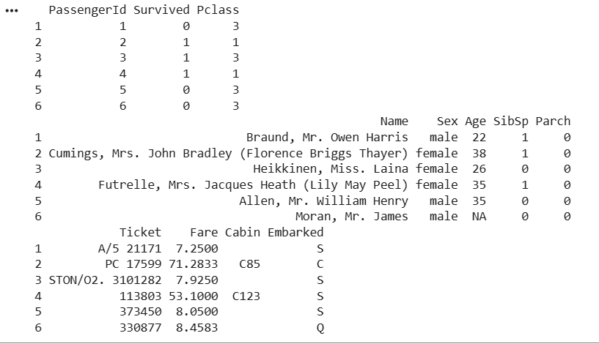
Initial Data Inspection:
str(data)
summary(data)
dim(data)
names(data)
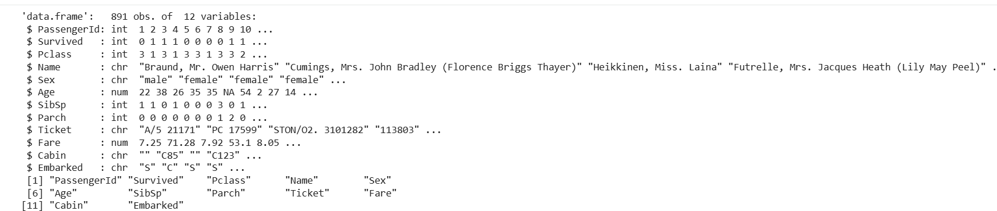
The dataset contains 891 observations and 12 variables. The str() function was used to understand the structure and data types, while summary() provided descriptive statistics. The dataset contains both numerical and categorical variables.

3.2 Missing Value Treatment
missing_values <- colSums(is.na(data))
print(missing_values)
total_missing <- sum(is.na(data))
print(total_missing)
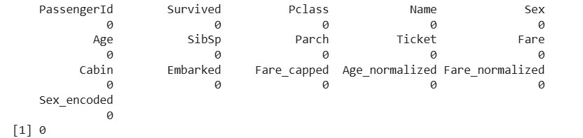
The missing-value analysis identified 177 missing values in the Age variable. No other variables contained NA values.
Missing Value Treatment:
median_age <- median(data$Age, na.rm = TRUE)
data$Age[is.na(data$Age)] <- median_age
colSums(is.na(data))
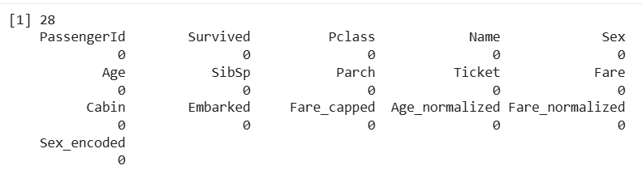
The missing Age values were replaced using median imputation. The calculated median age was 28 years. After imputation, the dataset was checked again and no NA values remained.
3.3 Duplicate Analysis
Duplicate Analysis:
duplicate_count <- sum(duplicated(data))
print(duplicate_count)
0 duplicates
Duplicate records were checked using the duplicated() function. The result was zero, indicating that the dataset did not contain duplicate records. Therefore, no rows were removed.
3.4 Outlier Detection and Treatment
A boxplot was created to visually identify potential outliers in the Fare variable. The plot shows several observations above the upper whisker, indicating the presence of potential outliers.
boxplot(
data$Fare,
main = "Fare Distribution and Outliers",
ylab = "Fare",
xlab = "Passenger Fare")
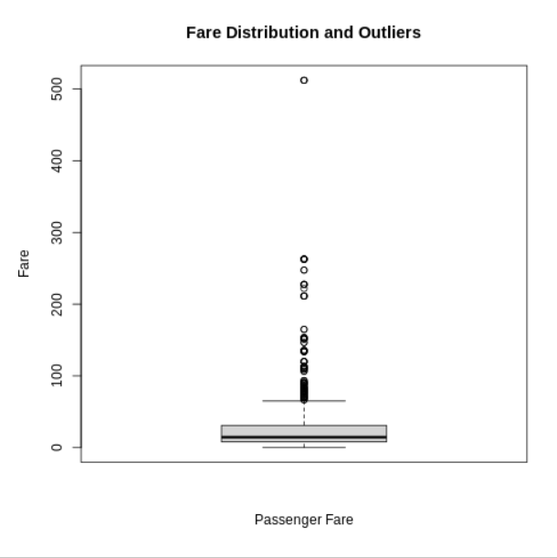
Figure: Fare Distribution and Potential Outliers
Q1 <- quantile(data$Fare, 0.25, na.rm = TRUE)
Q3 <- quantile(data$Fare, 0.75, na.rm = TRUE)
IQR_value <- IQR(data$Fare, na.rm = TRUE)
lower_limit <- Q1 - 1.5 * IQR_value
upper_limit <- Q3 + 1.5 * IQR_value
print(Q1)
print(Q3)
print(IQR_value)
print(lower_limit)
print(upper_limit)
Measure | Result
Q1 | 7.9104
Q3 | 31.0000
IQR | 23.0896
Lower Limit | -26.7240
Upper Limit | 65.6344
Number of Outliers | 116

Interpretation
Using the IQR method, the lower boundary was calculated as -26.7240 and the upper boundary as 65.6344. Since Fare values above 65.6344 were considered potential outliers, 116 observations were identified as outliers. These observations were retained and treated using the capping method in the next stage.
Outlier Treatment:
data$Fare_capped <- data$Fare
data$Fare_capped[data$Fare_capped > upper_limit] <- upper_limit
data$Fare_capped[data$Fare_capped < lower_limit] <- lower_limit
boxplot(
data$Fare_capped,
main = "Fare After Outlier Treatment",
ylab = "Fare",
xlab = "Passenger Fare"
)
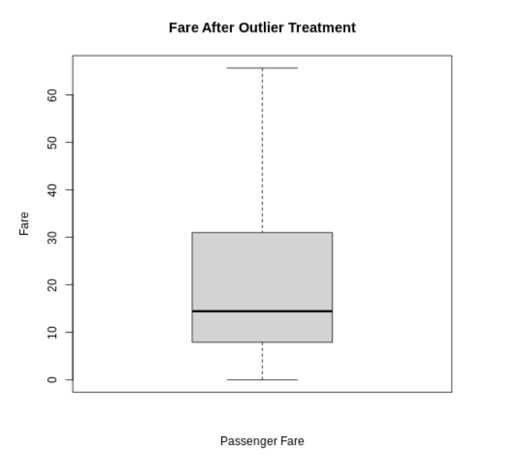
3.5 Normalization and Encoding
min_max <- function(x) {
(x - min(x, na.rm = TRUE)) /
(max(x, na.rm = TRUE) - min(x, na.rm = TRUE))
}
data$Age_normalized <- min_max(data$Age)
data$Fare_normalized <- min_max(data$Fare_capped)
summary(data$Age_normalized)
summary(data$Fare_normalized)
Min-Max normalization was applied to Age and the cleaned Fare variable. The transformed variables have values ranging from 0 to 1, making them suitable for analysis where variables need to be placed on a common scale.
Categorical Encoding:
Sex encoding
data$Sex_encoded <- ifelse(
data$Sex == "male",1,0)
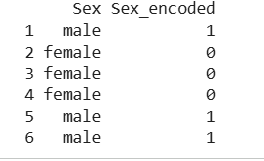
The Sex variable was binary encoded, with male represented as 1 and female represented as 0.
Embarked encoding
embarked_encoded <- model.matrix(
~ Embarked - 1,
data = data)
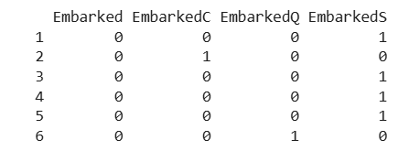
The Embarked variable was converted into separate binary variables using one-hot encoding. The resulting variables represent the three embarkation ports: C, Q and S.
Descriptive Statistics:
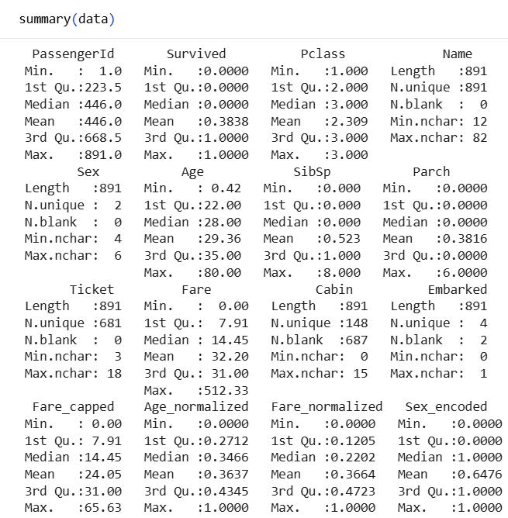
Variable | Mean | Median | Minimum | Maximum
Age | 29.36 | 28 | 0.42 | 80
SibSp | 0.52 | 0 | 0 | 8
Parch | 0.38 | 0 | 0 | 6
Fare | 32.20 | 14.45 | 0 | 512.33
Fare Capped | 24.05 | 14.45 | 0 | 65.63
The average passenger age was 29.36 years, while the median age was 28 years. The original Fare variable had a mean of 32.20 and a maximum of 512.33. After outlier treatment, the mean Fare decreased to 24.05 and the maximum became 65.63.
Exploratory Data Analysis:
Age Distribution
hist(
data$Age,
main = "Age Distribution of Passengers",
xlab = "Age",
ylab = "Frequency",
col = "lightblue",
border = "black"
)
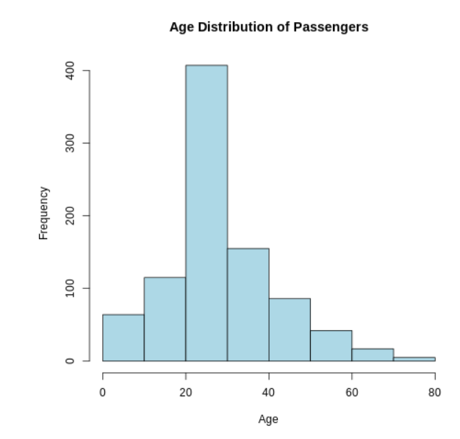
The histogram shows that most passengers were concentrated between approximately 20 and 40 years of age. The 20–30 age group had the highest frequency, while older age groups contained fewer passengers.
Survival by Gender
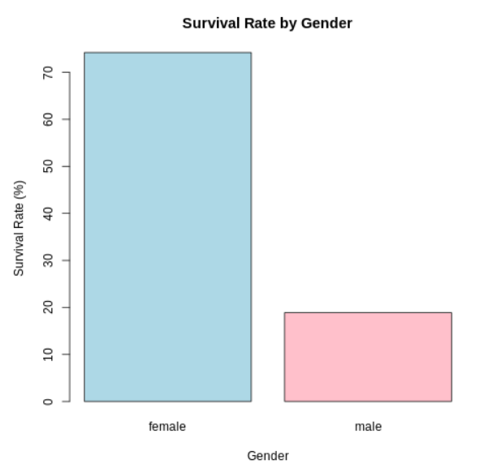
The analysis shows a substantial difference in survival rates between genders. Approximately 74% of female passengers survived, compared with approximately 19% of male passengers. This indicates a strong association between gender and survival in the dataset.
Survival by Passenger Class
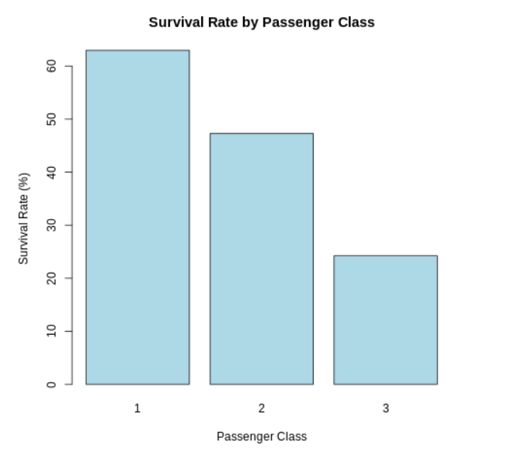
The analysis shows that survival rates differed across passenger classes. First Class passengers had the highest survival rate, followed by Second Class, while Third Class passengers had the lowest survival rate. This indicates an association between passenger class and survival in the Titanic dataset.
4.Data Visualization
4.1 Age Distribution
A histogram was selected to visualize the distribution of passenger ages. Histograms are useful for numerical variables because they group continuous values into intervals and display the frequency of observations in each interval. This visualization helps identify the most common age ranges, the spread of ages, and the overall shape of the distribution.
library(ggplot2)
ggplot(data, aes(x = Age)) +
geom_histogram(
bins = 30,
fill = "steelblue",
color = "white"
) +
labs(
title = "Age Distribution of Titanic Passengers",
x = "Age",
y = "Number of Passengers"
) +
theme_minimal()
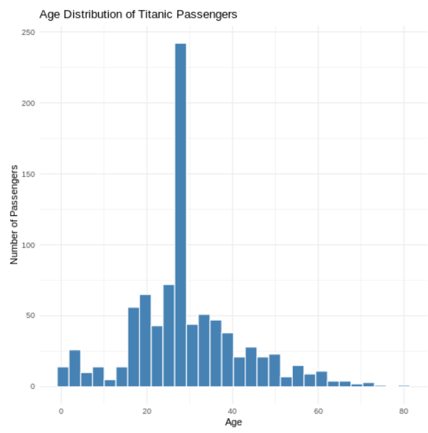
The histogram shows that passengers were distributed across a wide age range, from infants to approximately 80 years. The highest concentration of passengers is around the 20–30 age range, with the age of approximately 28 having the highest frequency. The number of passengers generally decreases as age increases beyond the 30–40 range. Therefore, the dataset contains a larger proportion of young and middle-aged passengers compared with older passengers.
4.2 Survival Status by Gender
A grouped bar chart was selected to compare the survival status of male and female passengers. Since Gender is a categorical variable and Survival Status has two categories, a bar chart provides a clear comparison of the number of passengers who survived and did not survive within each gender.
library(ggplot2)
ggplot(data, aes(x = Sex, fill = factor(Survived))) +
geom_bar(position = "dodge") +
labs(
title = "Survival Status by Gender",
x = "Gender",
y = "Number of Passengers",
fill = "Survival Status"
) +
scale_fill_manual(
values = c("0" = "gray", "1" = "steelblue"),
labels = c(
"0" = "Did Not Survive",
"1" = "Survived"
)
) +
theme_minimal()
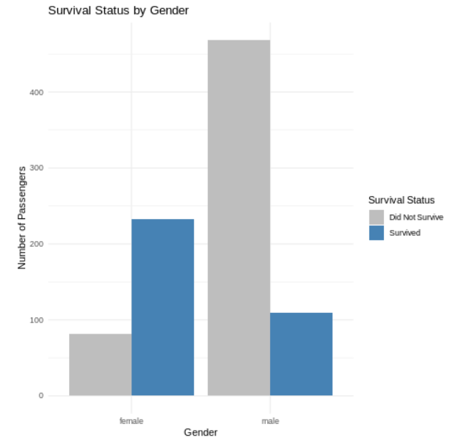
The visualization shows a clear difference in survival between male and female passengers. Among female passengers, the number of survivors is considerably higher than the number who did not survive. In contrast, among male passengers, the number of passengers who did not survive is much higher than the number who survived. This indicates a strong association between gender and survival in the Titanic dataset.
4.3 Survival Rate by Passenger Class
A bar chart was selected to compare the survival rates of passengers belonging to different passenger classes. The Pclass variable represents First Class, Second Class, and Third Class. Comparing survival rates across these categories helps identify whether passenger class was associated with survival.
class_rate <- aggregate(
Survived ~ Pclass,
data = data,
FUN = mean)
class_rate$Survival_Rate <- class_rate$Survived * 100
print(class_rate)
library(ggplot2)
ggplot(
class_rate,
aes(
x = factor(Pclass),
y = Survival_Rate)
) +
geom_col(fill = "steelblue") +
labs(
title = "Survival Rate by Passenger Class",
x = "Passenger Class",
y = "Survival Rate (%)"
) +
theme_minimal()
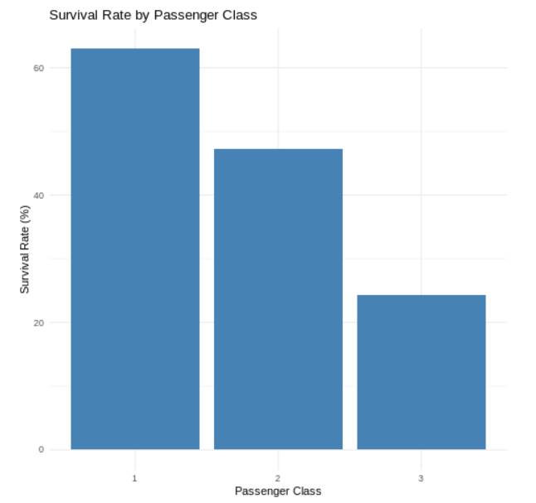
The visualization shows a clear difference in survival rates across passenger classes. First Class passengers had the highest survival rate, followed by Second Class passengers, while Third Class passengers had the lowest survival rate. The survival rate was approximately 63% for First Class, 47% for Second Class, and 24% for Third Class. This indicates a strong association between passenger class and survival.
4.4 Fare Distribution After Outlier Treatment
library(ggplot2)
ggplot(data, aes(x = Fare_capped)) +
geom_histogram(
bins = 30,
fill = "darkgreen",
color = "white"
) +
labs(
title = "Fare Distribution After Outlier Treatment",
x = "Fare",
y = "Number of Passengers"
) +
theme_minimal()
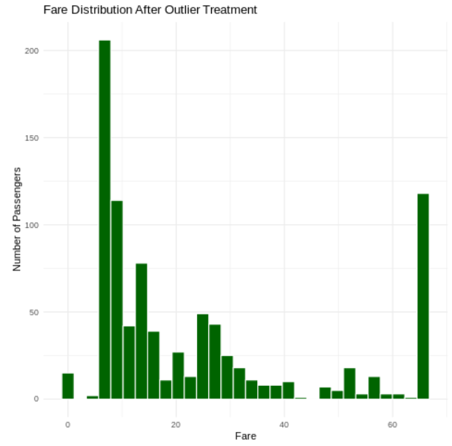
The histogram shows that most passengers paid relatively low fares, with the highest concentration occurring at the lower end of the fare range. The distribution is positively skewed, meaning that fewer passengers paid higher fares. After outlier treatment, the extreme fare values were capped at the calculated upper limit of 65.6344. This reduces the influence of unusually high fares while retaining the passenger records for further analysis.
4.5 Relationship Between Age and Fare
library(ggplot2)
ggplot(
data,
aes(
x = Age,
y = Fare_capped
)
) +
geom_point(alpha = 0.5) +
geom_smooth(
method = "lm",
se = TRUE
) +
labs(
title = "Relationship Between Age and Fare",
x = "Age",
y = "Fare"
) +
theme_minimal()
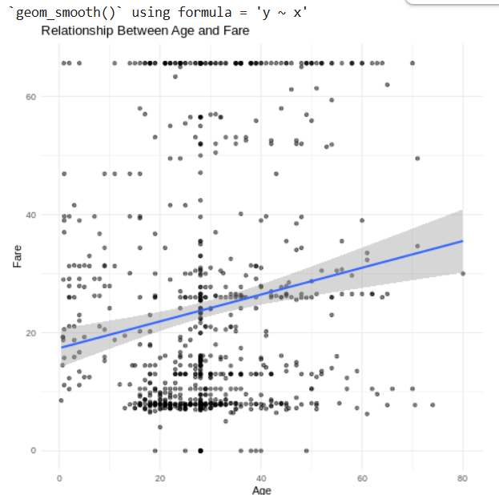
The scatter plot shows a large amount of variation in fare across different age groups. Most observations are concentrated in the lower fare range, while some passengers paid considerably higher fares. The regression line has a positive slope, suggesting a weak positive relationship between Age and Fare. However, the points are widely scattered around the trend line, indicating that age alone does not strongly explain the variation in fare.
4.6 Survival by Passenger Class and Gender
library(ggplot2)
ggplot(
data,
aes(
x = factor(Pclass),
fill = factor(Survived)
)
) +
geom_bar(position = "dodge") +
facet_wrap(~Sex) +
labs(
title = "Survival by Passenger Class and Gender",
x = "Passenger Class",
y = "Number of Passengers",
fill = "Survival Status"
) +
theme_minimal()
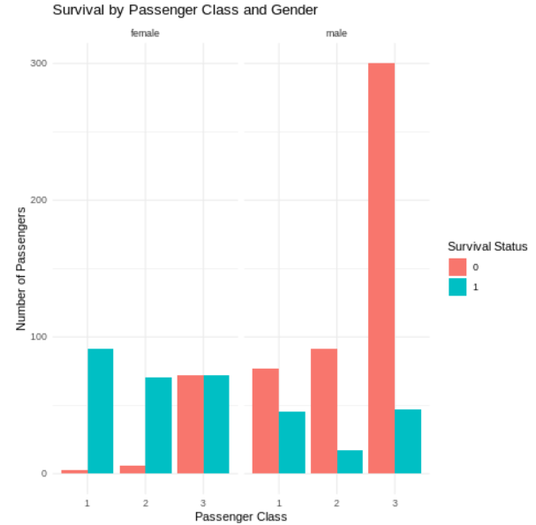
The visualization shows clear differences in survival patterns based on both gender and passenger class. Female passengers in First and Second Class had considerably more survivors than non-survivors. In Third Class, the numbers of female survivors and non-survivors were more similar. Among male passengers, non-survivors were substantially higher than survivors, particularly in Third Class. Overall, the visualization suggests that both gender and passenger class were important factors associated with survival.
4.7 Correlation Heatmap
cor_data <- data[, c(
"Survived",
"Pclass",
"Age",
"SibSp",
"Parch",
"Fare_capped"
)]

cor_matrix <- cor(
cor_data,
use = "complete.obs"
)

heatmap(
cor_matrix,
main = "Correlation Heatmap",
symm = TRUE
)
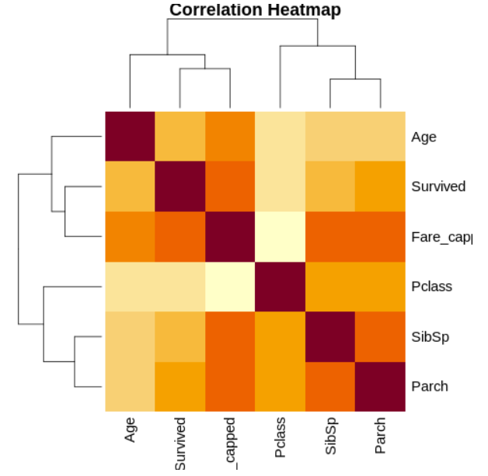
The heatmap shows that Pclass has a moderate negative relationship with Survived, while Fare_capped has a moderate positive relationship with Survived. Age, SibSp and Parch have relatively weak relationships with survival. The visualization also shows relationships among the other numerical variables, such as the relationship between SibSp and Parch.
5. Statistical Analysis
5.1 Descriptive Statistics
Descriptive statistics are used to summarize the main characteristics of the numerical variables. Measures such as mean, median, minimum and maximum help understand the data before performing statistical tests and predictive modeling.
summary(data[, c(
"Survived",
"Pclass",
"Age",
"SibSp",
"Parch",
"Fare_capped"
)])
cat("Mean Age:", mean(data$Age, na.rm = TRUE), "\n")
cat("Median Age:", median(data$Age, na.rm = TRUE), "\n")
cat("Mean Fare:", mean(data$Fare_capped, na.rm = TRUE), "\n")
cat("Median Fare:", median(data$Fare_capped, na.rm = TRUE), "\n")
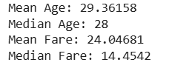
5.2 Correlation Analysis
Correlation analysis is used to examine the strength and direction of linear relationships between numerical variables. Pearson correlation values range from -1 to +1. Values closer to zero indicate a weak linear relationship, while values closer to -1 or +1 indicate a stronger relationship.
cor_data <- data[, c(
"Survived",
"Pclass",
"Age",
"SibSp",
"Parch",
"Fare_capped"
)]
cor_matrix <- cor(
cor_data,
use = "complete.obs"
)
print(round(cor_matrix, 3))
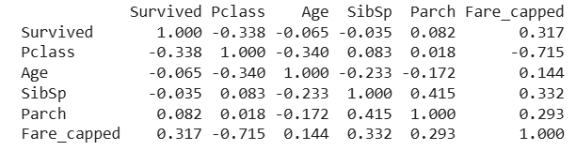
5.3 Shapiro-Wilk Normality Test
Normality Test
A normality test is performed to determine whether the distribution of a numerical variable approximately follows a normal distribution. The Shapiro-Wilk test is used for this purpose.
Hypotheses:
- H₀: The Age variable follows a normal distribution.
- H₁: The Age variable does not follow a normal distribution.
Result:
The Shapiro-Wilk test produced a W statistic of 0.9519 and a p-value of 1.102 × 10⁻¹¹. Since the p-value is less than the significance level of 0.05, the null hypothesis is rejected. Therefore, the Age variable does not follow a normal distribution.
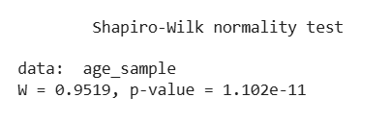
5.4 Chi-Square Test
Hypothesis Testing
Chi-Square Test: Gender vs Survival
Hypotheses
H₀ (Null Hypothesis):Gender and survival are independent.
H₁ (Alternative Hypothesis):Gender and survival are significantly associated.
gender_table <- table(
data$Sex,
data$Survived
)
print(gender_table)
chi_gender <- chisq.test(gender_table)
print(chi_gender)
The Chi-square test produced a test statistic of 260.72 with 1 degree of freedom and a p-value less than 2.2 × 10⁻¹⁶. Since the p-value is much smaller than 0.05, the null hypothesis is rejected. Therefore, there is a statistically significant association between gender and survival among the passengers in the dataset.
Gender appears to be significantly associated with survival in the Titanic dataset.
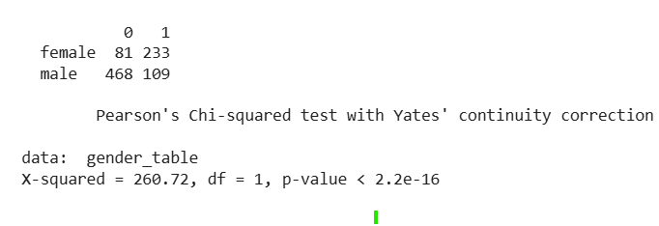
6.Predictive Modeling
6.1Train-Test Split
The dataset was divided into training and testing sets using an 80:20 ratio. The training dataset contains 712 records, while the testing dataset contains 179 records. A random seed of 123 was used to make the split reproducible.
set.seed(123)
n <- nrow(data)
train_index <- sample(
1:n,
size = 0.8 * n)
train_data <- data[train_index, ]
test_data <- data[-train_index, ]
cat("Training rows:", nrow(train_data), "\n")
cat("Testing rows:", nrow(test_data), "\n")
6.2Logistic Regression Model
Logistic regression was selected because the target variable Survived has two possible outcomes: 0 and 1. The model uses passenger class, gender, age, family information and fare to predict the probability of survival.
R code:
model <- glm(
Survived ~ Pclass + Sex + Age + SibSp + Parch + Fare_capped,
data = train_data,
family = binomial
)
summary(model)
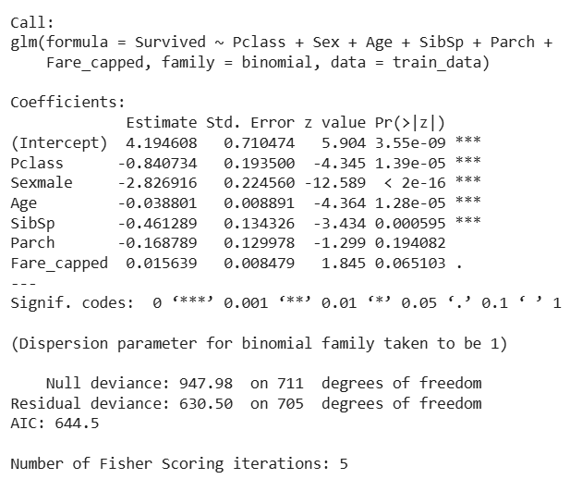
The logistic regression model was developed using Pclass, Sex, Age, SibSp, Parch, and Fare_capped as predictor variables. The results show that Pclass, Sex, Age, and SibSp have statistically significant effects on survival because their p-values are below 0.05. Parch is not statistically significant, while Fare_capped is also not significant at the 5% level. The negative coefficients for Pclass, SexMale, Age, SibSp and Parch indicate a decrease in the log-odds of survival as these variables increase or for the male category compared with the reference female category.
The model has a null deviance of 947.98 and residual deviance of 630.50. The AIC value is 644.5.
6.3 Model Predictions
After training the logistic regression model, predictions were generated for the test dataset. The model first calculates the probability of survival for each passenger. A threshold of 0.5 was used to convert these probabilities into binary predictions. A probability of 0.5 or higher is classified as survived (1), while a probability below 0.5 is classified as did not survive (0).
probabilities <- predict(
model,
newdata = test_data,
type = "response"
)
predictions <- ifelse(
probabilities >= 0.5,
1,
0
)
print(head(probabilities))
print(head(predictions))
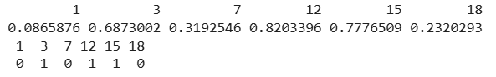
6.4 Confusion Matrix
A confusion matrix is used to compare the actual outcomes with the predicted outcomes of the classification model. It shows true positives, true negatives, false positives, and false negatives, which are used to calculate different model performance metrics.
actual <- test_data$Survived
confusion_matrix <- table(
Actual = actual,
Predicted = predictions)
print(confusion_matrix)
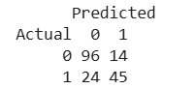
6.5 Model Performance Metrics
The logistic regression model was evaluated using accuracy, precision, recall, and F1-score. These metrics provide different measures of how well the model predicts passenger survival.
TN <- confusion_matrix[1,1]
FP <- confusion_matrix[1,2]
FN <- confusion_matrix[2,1]
TP <- confusion_matrix[2,2]
accuracy <- (TP + TN) / (TP + TN + FP + FN)
precision <- TP / (TP + FP)
recall <- TP / (TP + FN)
f1_score <- 2 * (precision * recall) / (precision + recall)
cat("Accuracy :", round(accuracy, 4), "\n")
cat("Precision:", round(precision, 4), "\n")
cat("Recall :", round(recall, 4), "\n")
cat("F1 Score :", round(f1_score, 4), "\n")
Metric | Result
Accuracy | 78.77%
Precision | 76.27%
Recall | 65.22%
F1-Score | 70.31%

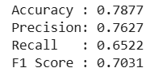
The logistic regression model achieved an accuracy of 78.77%, meaning that approximately 79% of the test observations were classified correctly. The precision was 76.27%, indicating that most passengers predicted as survivors were actually survivors. The recall was 65.22%, showing that the model correctly identified about 65% of the actual survivors. The F1-score was 70.31%, providing a balance between precision and recall. Overall, the model provided a reasonable level of predictive performance on the test dataset.
6.6 Model Diagnostics
Diagnostic Plots
Model diagnostic plots were used to examine the behavior of the logistic regression model and identify possible issues such as unusual observations, non-constant residual patterns, and influential points. Four diagnostic plots were generated: Residuals vs Fitted, Q-Q Residuals, Scale-Location, and Residuals vs Leverage.

par(mfrow = c(2, 2))
plot(model)
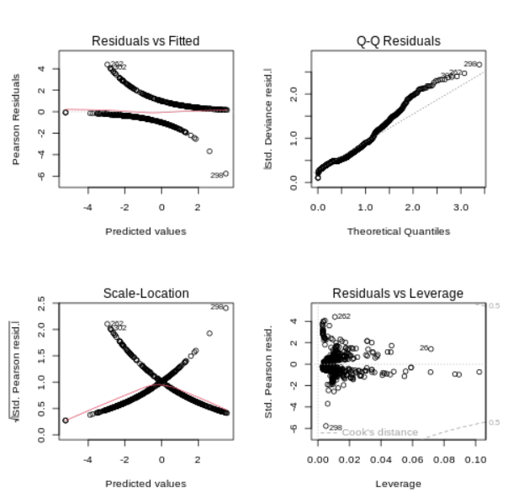
The Residuals vs Fitted plot shows the distribution of residuals across the fitted values and indicates some variation in the residual patterns. The Q-Q plot shows deviations from the reference line, suggesting that the residuals are not perfectly normally distributed. The Scale-Location plot shows variation in the spread of residuals across fitted values. The Residuals vs Leverage plot helps identify observations with relatively high leverage. Overall, the diagnostic plots indicate that the model has some limitations and that further feature engineering or alternative modeling techniques could potentially improve the predictions.

6.7 5-Fold Cross-Validation
5-fold cross-validation was used to check whether the logistic regression model performs consistently across different subsets of the dataset. The data was divided into five folds. In each iteration, four folds were used for training and the remaining fold was used for testing. This process was repeated five times, and the accuracy from each fold was recorded.
set.seed(123)
k <- 5
folds <- sample(
rep(1:k, length.out = nrow(data))
)
cv_accuracy <- numeric(k)
for (i in 1:k) {
cv_train <- data[folds != i, ]
cv_test <- data[folds == i, ]
cv_model <- glm(
Survived ~ Pclass + Sex + Age + SibSp + Parch + Fare_capped,
data = cv_train,
family = binomial
)
cv_prob <- predict(
cv_model,
newdata = cv_test,
type = "response"
)
cv_pred <- ifelse(
cv_prob >= 0.5,
1,
0
)
cv_accuracy[i] <- mean(
cv_pred == cv_test$Survived
)
}
print(cv_accuracy)
cat(
"Mean 5-Fold Cross-Validation Accuracy:",
round(mean(cv_accuracy), 4),
"\n"
)
The five folds produced accuracy values between 74.72% and 83.15%. The mean cross-validation accuracy was 78.56%. This is close to the test-set accuracy of 78.77%, indicating that the model provides reasonably consistent performance across different subsets of the data.
7. Overall Results and Discussion
The complete analysis provided useful insights into the Titanic passenger dataset. The data preparation stage handled missing Age values, duplicate records and extreme Fare values. The visualization stage helped identify clear differences in survival based on gender and passenger class. The statistical analysis confirmed a significant relationship between gender and survival. The logistic regression model achieved 78.77% accuracy on the test data, while five-fold cross-validation produced an average accuracy of 78.56%. Overall, the results show that passenger characteristics such as gender and passenger class are important factors related to survival.
8. Challenges Faced
During the project, some challenges were faced while handling missing values, identifying Fare outliers, encoding categorical variables and preparing the data for modeling. Another challenge was understanding the results of statistical tests and model evaluation metrics. These issues were handled by using appropriate R functions and checking the outputs at each stage.
9. Future Scope
The analysis can be improved by testing other machine learning algorithms such as Decision Tree, Random Forest and Support Vector Machine. Feature engineering and parameter tuning could also be performed to improve prediction accuracy. Additional datasets could be used in future work to compare the results and develop more reliable predictive models.
10. Conclusion
This project covered the complete data analysis process using R, starting from data cleaning and preprocessing and continuing through visualization, statistical analysis and predictive modeling. The Titanic dataset was useful for understanding relationships between passenger characteristics and survival. The analysis showed clear differences in survival based on gender and passenger class. Statistical testing supported these observations, and the logistic regression model achieved reasonable predictive performance. Overall, the project provided practical experience in R-based data analysis and helped develop skills in data preparation, visualization, statistical testing and machine learning.
11. Appendix — Complete R Code
data <- read.csv("/content/train.csv")
head(data)
str(data)
summary(data)
dim(data)
names(data)
missing_values <- colSums(is.na(data))
median_age <- median(data$Age, na.rm = TRUE)
data$Age[is.na(data$Age)] <- median_age
duplicate_count <- sum(duplicated(data))
Q1 <- quantile(data$Fare, 0.25, na.rm = TRUE)
Q3 <- quantile(data$Fare, 0.75, na.rm = TRUE)
IQR_value <- IQR(data$Fare, na.rm = TRUE)
lower_limit <- Q1 - 1.5 * IQR_value
upper_limit <- Q3 + 1.5 * IQR_value
outliers <- data$Fare[
data$Fare < lower_limit |
data$Fare > upper_limit]
data$Fare_capped <- data$Fare
data$Fare_capped[data$Fare_capped > upper_limit] <- upper_limit
min_max <- function(x) {
(x - min(x, na.rm = TRUE)) /
(max(x, na.rm = TRUE) - min(x, na.rm = TRUE))
}
data$Age_normalized <- min_max(data$Age)
data$Fare_normalized <- min_max(data$Fare_capped)

data$Sex_encoded <- ifelse(data$Sex == "male", 1, 0)
embarked_encoded <- model.matrix(
~ Embarked - 1,
data = data)
numeric_data <- data[, c(
"Survived",
"Pclass",
"Age",
"SibSp",
"Parch",
"Fare_capped")]
cor_matrix <- cor(
numeric_data,
use = "complete.obs")
heatmap(
cor_matrix,
main = "Correlation Matrix",
symm = TRUE)

library(ggplot2)
ggplot(data, aes(x = Age)) +
geom_histogram(
bins = 30,
fill = "steelblue",
color = "white"
) +
labs(
title = "Age Distribution of Titanic Passengers",
x = "Age",
y = "Number of Passengers"
) +
theme_minimal()
ggplot(data, aes(x = Sex, fill = factor(Survived))) +
geom_bar(position = "dodge") +
labs(
title = "Survival Status by Gender",
x = "Gender",
y = "Number of Passengers",
fill = "Survival Status"
) +
scale_fill_manual(
values = c("0" = "gray", "1" = "steelblue"),
labels = c(
"0" = "Did Not Survive",
"1" = "Survived"
)
) +
theme_minimal()
class_rate <- aggregate(
Survived ~ Pclass,
data = data,
FUN = mean
)
class_rate$Survival_Rate <- class_rate$Survived * 100
print(class_rate)
ggplot(
class_rate,
aes(
x = factor(Pclass),
y = Survival_Rate
)
) +
geom_col(fill = "steelblue") +
labs(
title = "Survival Rate by Passenger Class",
x = "Passenger Class",
y = "Survival Rate (%)"
) +
theme_minimal()
ggplot(data, aes(x = Fare_capped)) +
geom_histogram(
bins = 30,
fill = "darkgreen",
color = "white"
) +
labs(
title = "Fare Distribution After Outlier Treatment",
x = "Fare",
y = "Number of Passengers"
) +
theme_minimal()
ggplot(
data,
aes(
x = Age,
y = Fare_capped
)
) +
geom_point(alpha = 0.5) +
geom_smooth(
method = "lm",
se = TRUE
) +
labs(
title = "Relationship Between Age and Fare",
x = "Age",
y = "Fare"
) +
theme_minimal()
ggplot(
data,
aes(
x = factor(Pclass),
fill = factor(Survived)
)
) +
geom_bar(position = "dodge") +
facet_wrap(~Sex) +
labs(
title = "Survival by Passenger Class and Gender",
x = "Passenger Class",
y = "Number of Passengers",
fill = "Survival Status"
) +
theme_minimal()
cor_data <- data[, c(
"Survived",
"Pclass",
"Age",
"SibSp",
"Parch",
"Fare_capped"
)]
cor_matrix <- cor(
cor_data,
use = "complete.obs"
)
print(round(cor_matrix, 3))
heatmap(
cor_matrix,
main = "Correlation Heatmap",
symm = TRUE
)
set.seed(123)
summary(data[, c(
"Survived",
"Pclass",
"Age",
"SibSp",
"Parch",
"Fare_capped"
)])
cat("Mean Age:", mean(data$Age, na.rm = TRUE), "\n")
cat("Median Age:", median(data$Age, na.rm = TRUE), "\n")
cat("Mean Fare:", mean(data$Fare_capped, na.rm = TRUE), "\n")
cat("Median Fare:", median(data$Fare_capped, na.rm = TRUE), "\n")
cor_data <- data[, c(
"Survived",
"Pclass",
"Age",
"SibSp",
"Parch",
"Fare_capped"
)]
cor_matrix <- cor(
cor_data,
use = "complete.obs"
)
print(round(cor_matrix, 3))
age_sample <- sample(
data$Age,
min(500, length(data$Age))
)
shapiro_result <- shapiro.test(age_sample)
print(shapiro_result)
gender_table <- table(
data$Sex,
data$Survived
)
print(gender_table)
chi_gender <- chisq.test(gender_table)
print(chi_gender)
n <- nrow(data)
train_index <- sample(
1:n,
size = 0.8 * n
)
train_data <- data[train_index, ]
test_data <- data[-train_index, ]
cat("Training rows:", nrow(train_data), "\n")
cat("Testing rows:", nrow(test_data), "\n")
model <- glm(
Survived ~ Pclass + Sex + Age + SibSp + Parch + Fare_capped,
data = train_data,
family = binomial
)
summary(model)
probabilities <- predict(
model,
newdata = test_data,
type = "response"
)
predictions <- ifelse(
probabilities >= 0.5,
1,
0
)
print(head(probabilities))
print(head(predictions))
actual <- test_data$Survived
confusion_matrix <- table(
Actual = actual,
Predicted = predictions
)
print(confusion_matrix)
TN <- confusion_matrix[1,1]
FP <- confusion_matrix[1,2]
FN <- confusion_matrix[2,1]
TP <- confusion_matrix[2,2]
accuracy <- (TP + TN) / (TP + TN + FP + FN)
precision <- TP / (TP + FP)
recall <- TP / (TP + FN)
f1_score <- 2 * (precision * recall) / (precision + recall)
cat("Accuracy :", round(accuracy, 4), "\n")
cat("Precision:", round(precision, 4), "\n")
cat("Recall :", round(recall, 4), "\n")
cat("F1 Score :", round(f1_score, 4), "\n")
par(mfrow = c(2, 2))
plot(model)
set.seed(123)
k <- 5
folds <- sample(
rep(1:k, length.out = nrow(data))
)
cv_accuracy <- numeric(k)
for (i in 1:k) {
cv_train <- data[folds != i, ]
cv_test <- data[folds == i, ]
cv_model <- glm(
Survived ~ Pclass + Sex + Age + SibSp + Parch + Fare_capped,
data = cv_train,
family = binomial
)
cv_prob <- predict(
cv_model,
newdata = cv_test,
type = "response"
)
cv_pred <- ifelse(
cv_prob >= 0.5,
1,
0
)
cv_accuracy[i] <- mean(
cv_pred == cv_test$Survived
)
}
print(cv_accuracy)
cat(
"Mean 5-Fold Cross-Validation Accuracy:",
round(mean(cv_accuracy), 4),
"\n"
)

